Today we are going to see how we can delete a file from git repository.

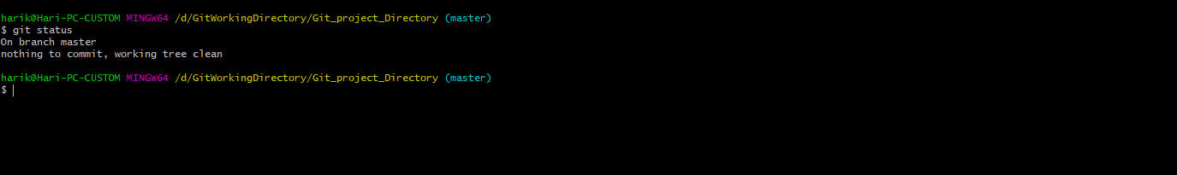

Now if you want to delete some file go to that directory and delete it.

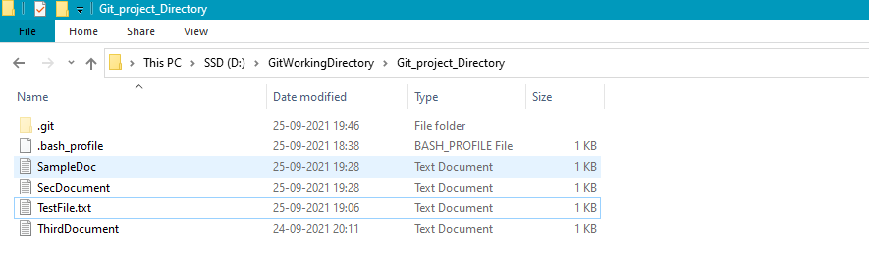

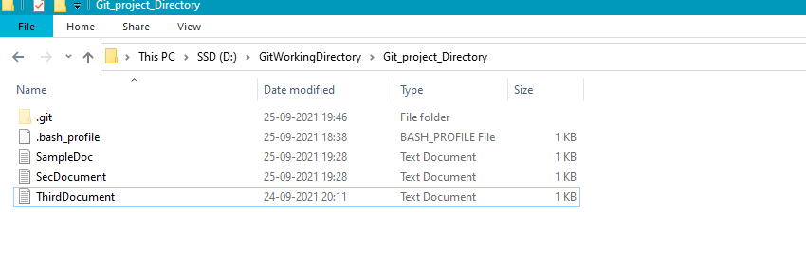

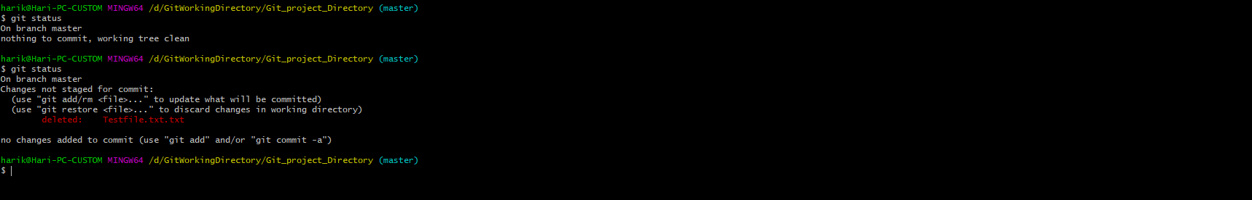

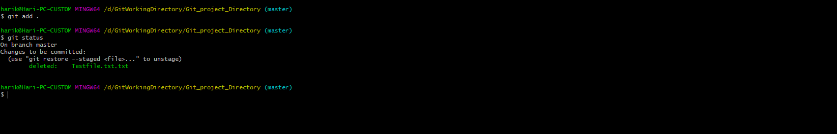

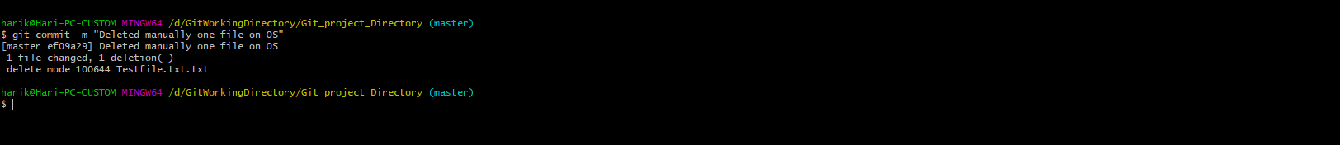

There is one more way to delete a file on git using “git rm”

# git rm ThirdDocument.txt

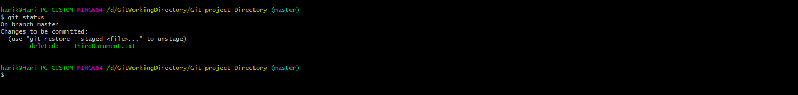

Note: The difference by removing git rm command is we are skipping the command “git add” which is not the case when we delete the file on OS side.

